Ex1
To apply one writer many readers we have to edit the following stuff in the code:
- transform sharedValue to volatile
- edit run method of the threads, saving only once time the shared variable. All operation will performed on this value.
- Remove explicit lock
the problem generated by multiple reader of the shared value from thread is data read in the previous line might be different and so some operations couldn’t be coherent.

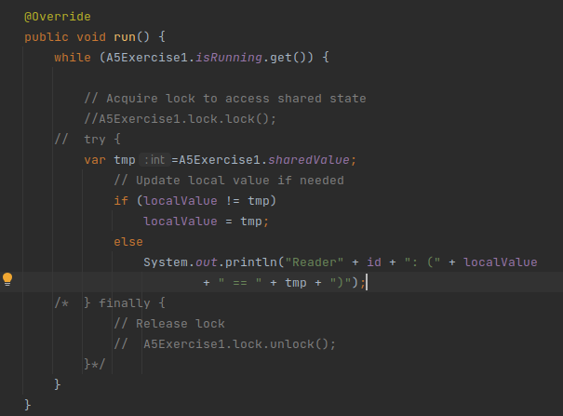
Value is saved in tmp and than all operation will be performed on tmp variable and not on sharedValue.

